SAVE THE DATE

2020 Traditional Ecological
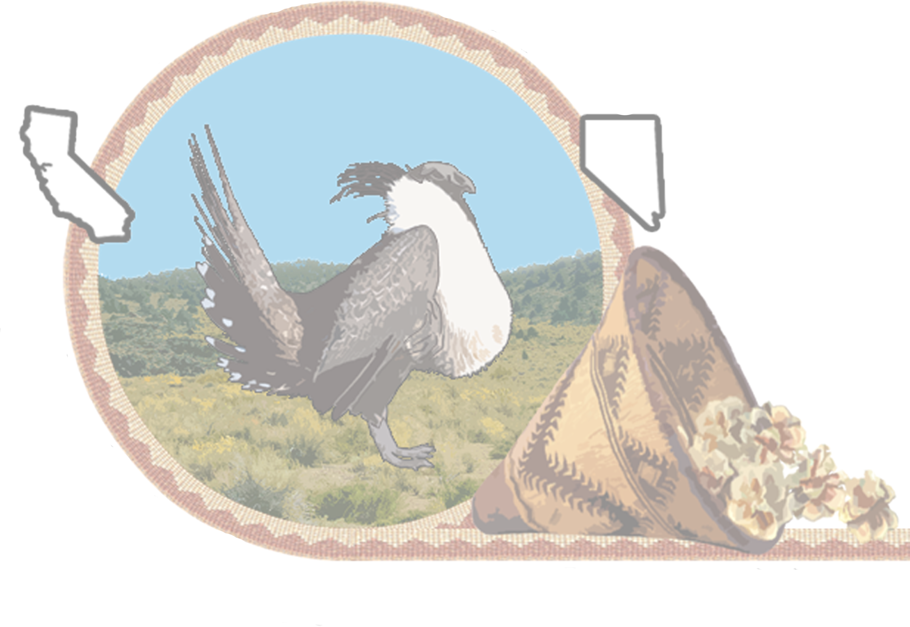
Knowledge (TEK) Summit

*June 3-4, 2020*

Organized by the Bi-State Tribal Natural Resources Committee (BTNRC)

The mission of the Bi-State Tribal Natural Resources Committee (BTNRC) is to promote, protect and preserve good management of lands in the bi-state through advocacy and education using a holistic approach. The purpose of the Committee is to educate and facilitate communication between tribes and land management agencies. The Committee is made up of official representatives of the Tribes in the Bi-State area, individual Tribal members, and representatives of the land and wildlife
management agency units.

To register online please visit: http://tiny.cc/TEKSummit2020

For more information please contact: btnrcteksummit@gmail.com

