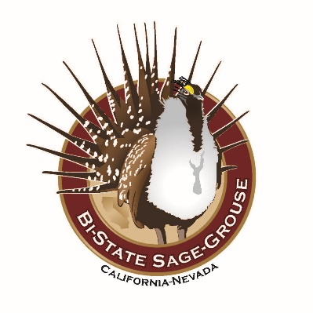
BI-STATE LOCAL AREA WORKING GROUP

DRAFT MEETING AGENDA

Date: June 5, 2019
Time: 12:00 PM –3:00 PM
Location: Antelope Valley Community Center, Walker, CA

12:00-12:15 Welcome & Introductions (All)
- Changes/additions to the agenda
- Changes in staff

12:15-12:45 USFWS Listing Decision Update (Steve Abele)

12:45-1:00 EOC Update (Steve Nelson)
- Updated Agency Commitment Letters
- LADWPs involvement in the Bi-State Partnership

1:00-1:20 2012-2018 Accomplishment Report (Amy Sturgill)

1:20-1:30 BREAK

1:30-1:40 West Wide Energy Corridor Project
(Jora Fogg/Apil Sall/Laura Cunningham)

1:40-2:30 2019 Fieldwork Update
- 2019 Captures & monitoring (USGS-10 min)
- Parker translocation (USGS-10min)
- Sage-grouse behavioral study (UC Davis-10min)
- NV lek counts (NDOW/BLM-10 min)
- CA lek counts (CDFW/BLM-10 min)

2:30-2:45 Project updates (All)

2:45 Next Meeting

